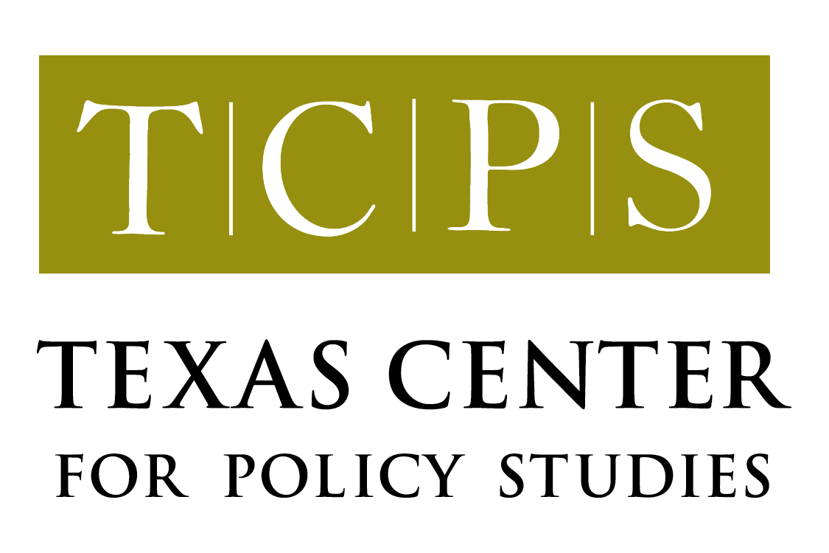

SHARING THE WATERS: U.S. AND MEXICO MUST COOPERATE

Mary E. Kelly and Karen Chapman

May 2002

“A phenomenon noticeable throughout history regardless of place or period is the pursuit by governments of policies contrary to their own interests.”

Barbara Tuchman, The March of Folly (1984)

The Río Bravo no longer reaches the Gulf of Mexico—it’s blocked by a sandbar that is the result of several years of low flow in the river. This development is symbolic of the dire state of the entire transboundary Río Bravo basin. And the river’s troubles are now manifesting themselves in an increasingly acrimonious dispute between the United States and Mexico.

Charges and countercharges are flying over water allocation in the Río Bravo basin. Some Texas politicians are threatening “retaliation” over what they say is Mexico’s failure to live up to its obligations under the 1944 Treaty that governs how the waters of this vitally important river basin are to be shared. They seem to be agreeing with the position of farmers in the Lower Rio Grande Valley of Texas that Mexico is somehow managing its part of the basin to deliberately withhold water and put Texas farmers out of business. They have mounted a sustained campaign to convince U.S. federal officials that Mexico should be passing water through to the Río Grande instead of using for irrigation in Chihuahua.

What the Texas sometimes claims fail to acknowledge, however, is that northern Mexico is suffering from a severe and persistent drought that has reduced capacity in its reservoirs to dangerously low levels. One of the largest reservoirs in the Mexican portion of the basin, La Boquilla on the Río Conchos in Chihuahua, is at about 20% of normal capacity; further down the Conchos, the Luís León reservoir has only 13 % of its normal storage; and Mexico’s share in the joint Amistad/Falcon Reservoir system is less than 10% of its capacity. Under these conditions, short of cutting off all irrigation, it is not practical for Mexico to rapidly repay its current deficit of about 1.4 million acre-feet under the Treaty, as many in Texas are demanding.

To date, most federal officials in Washington, D.C. have maintained a low profile with regard to negotiations on the issue. Nevertheless, the constant pressure from Texas, widespread media coverage and the lack of perceived progress in resolving the dispute, may begin to make that approach more difficult to sustain.

The fact that Mexico does bear some responsibility for the current situation cannot be ignored. A clear-eyed look at the last decade of water management, particularly in the Río Conchos basin, indicates that during 1996 and 1997, at least, water managers did not cut back irrigation in response to the on-going drought. They may have thought that the relatively good rains in those years meant the drought was over. Or they may have been counting a good hurricane or two to fill up the dams and wipe the deficit from the books. Whatever the reason, reserves were drawn down to very low levels—and the rains never came.

Mexico also faces some difficult internal challenges in managing its share of the Río Bravo basin. For example, there is no formal agreement among the border states about how the Mexican portion of the waters will be divided. Thus, Tamaulipas—as the downriver state—is largely at the mercy of how much water is used in Chihuahua. And Tamaulipas farmers have suffered enormously over the last few years, receiving less and less Río Bravo water for irrigation. Most of these farmers are now growing only dryland crops like grain sorghum.

Where should the governments go from here? A standoff over interpretation of the 1944 Treaty isn’t going to solve any problems, and neither will repeated demands for impractical actions. Further escalation of this dispute can only cause damage to our important bilateral relationship, affecting our countries’ ability to cooperate on important water issues in other parts of the border. (For example, in Cd. Juárez/El Paso local interests are working hard to develop a joint management plan for the Hueco Bolson aquifer and in the ecologically valuable Colorado Delta in the Gulf of California restoration proposals are generating strong binational support). An escalated dispute could also threaten progress on immigration, economic development, infrastructure or other issues.

The interests of both governments, and those of the people that depend on the Río Bravo, will best be served by cooperation and negotiation. There are several areas where short-term progress is possible. First, the governments must quickly agree on a formula for allocating what rain does fall this year. There will probably be objections to any formula: Chihuahua irrigators may not want to give up any of the water and Texas farmers may feel that anything less than full payment of the deficit is insufficient. These objections might be overcome by federal efforts to compensate farmers’ legitimate documented losses and to invest in improving the efficiency of irrigation systems on both sides of the border.

Second, the governments should come to agreement by the end of this year on a drought management plan for the Río Bravo basin. If the current crisis has demonstrated anything, it is that we lack a plan for dealing with drought. The plan should include: criteria for recognizing when a drought is taking hold; steps to manage the basin’s most important reservoirs in time of drought; and provisions for expanded, internet-accessible monitoring of stream flows, so all concerned can better understand the state of the basin during critical low rainfall periods.

Third, the U.S. and Mexico need to develop a payment plan for the current deficit. Realistically, it is highly unlikely that Mexico can repay that debt before the current 5-year accounting cycle under the treaty runs out in October 2002. But, negotiating a realistic plan, based on the actual rainfall that does occur (not what is predicted) could help defuse tensions.

Finally, the governments should convene a binational summit to develop an overall sustainable management plan for the basin, involving key water user groups, conservation organizations and state and local governments. This concept was originally proposed by Mexico and embodied in a March 2001 agreement between the countries. However, the current dispute appears to have stalled action on the idea.

In early May, Mexican and U.S. conservation organizations convened a forum in Chihuahua to discuss what cooperative actions can be taken to protect and restore the Río Conchos basin. This meeting focused not on the water deficit but on cooperatively developing some specific ideas for making progress. Here’s hoping the governments recognize their interests in doing the same.

Proceedings from this conference will be available in late June 2002 on the TCPS web site.

