The Dispute Over Shared Waters of the
Río Grande/Río Bravo

A Primer

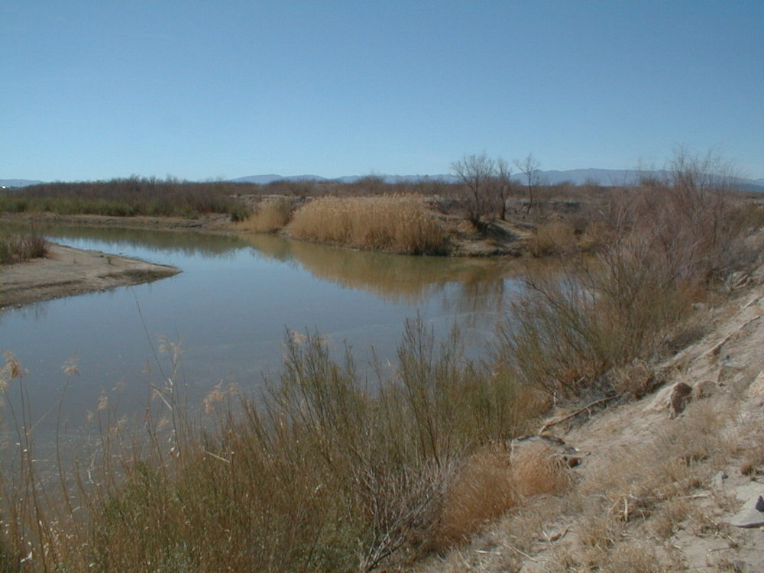
Photo: The Confluence of the Río Grande and Río Conchos near Presidio/Ojinaga

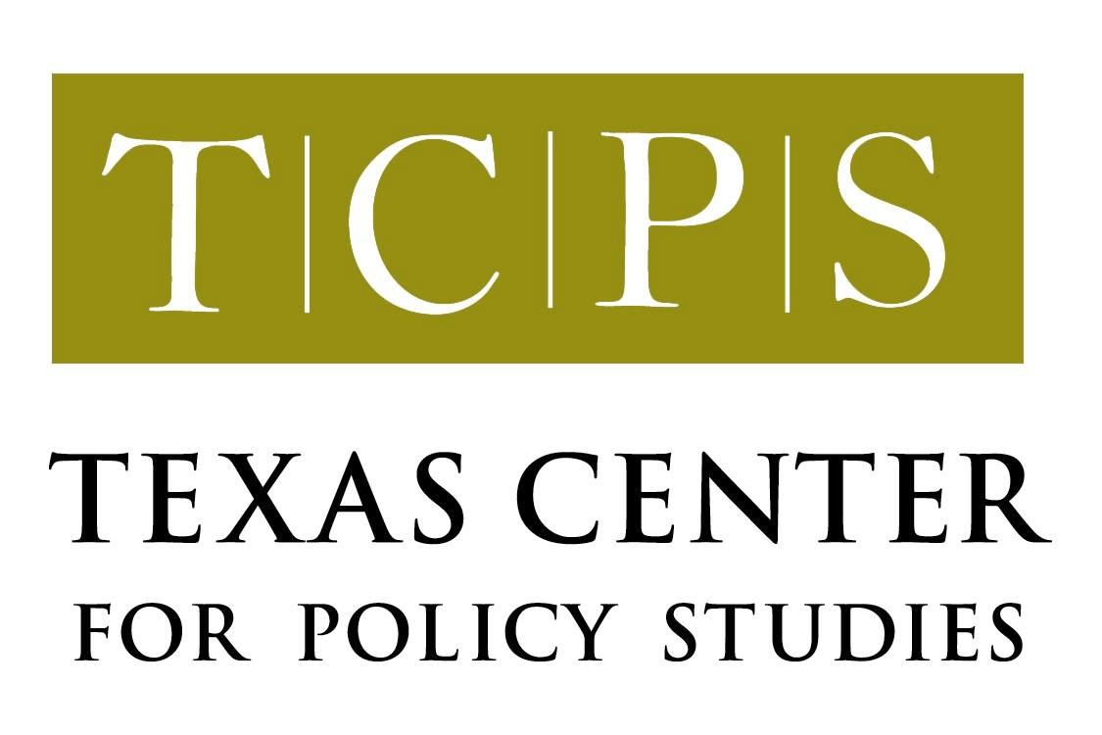

www.texascenter.org/borderwater

July, 2002
Overview

This short primer is intended to provide a brief explanation of the current dispute over the binational waters of the Río Grande/Río Bravo. It provides information on the drought and reservoir levels in the basin and trends in irrigation use and crop production in two key areas: the Río Conchos basin in Chihuahua and the Lower Rio Grande Valley (LRGV) of Texas. It also summarizes the positions taken by Texas elected officials, the U.S. State Department, the Secretaria de Relaciones Exteriores de Mexico, and the International Boundary and Water Commission/Comision Internacional de Limites y Aguas, as reported in the press and in official communications.

Appendix A contains a bibliography of sources used in preparing this primer, as well as a resource list and internet links for those interested in more detailed information.

Drought and Water Deliveries

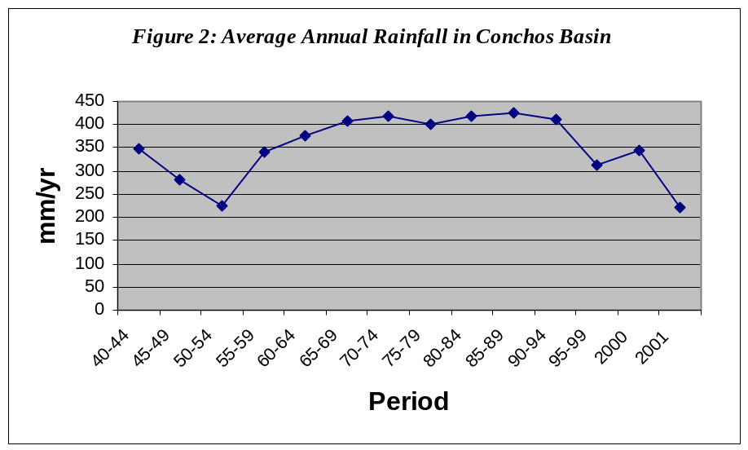Estimates vary, but the drought that currently casts a pall over the Texas/Mexico portion of the Rio Grande Basin is estimated to have officially begun in 1993 (USDA 2002). This drought is the most serious one affecting the basin since the completion of Amistad International Dam in 1969 (USDA). The Palmer Drought Severity Index (see Figure 1) shows that the Lower Rio Grande Valley is currently in “extreme” drought. All northern Mexican states and the Lower Rio Grande Valley have been declared drought disaster areas several times within the past nine years (USDA, SAGARPA). Figure 2 shows rainfall trends in the Conchos basin, while Figure 3 presents rainfall data for the LRGV. In June 2002, the Mexican federal government declared 50 of 62 cities in Chihuahua (including many in the Sierra Tarahumara) disaster areas, making them eligible to receive federal relief funds (La Jornada, June 12, 2002).
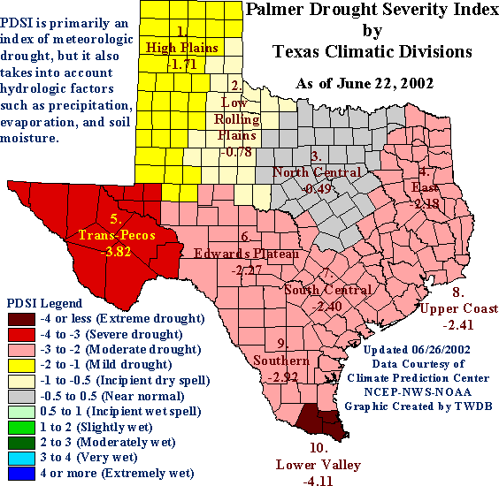
Figure 1
Figure 3 Average for time period: 24 inches per year
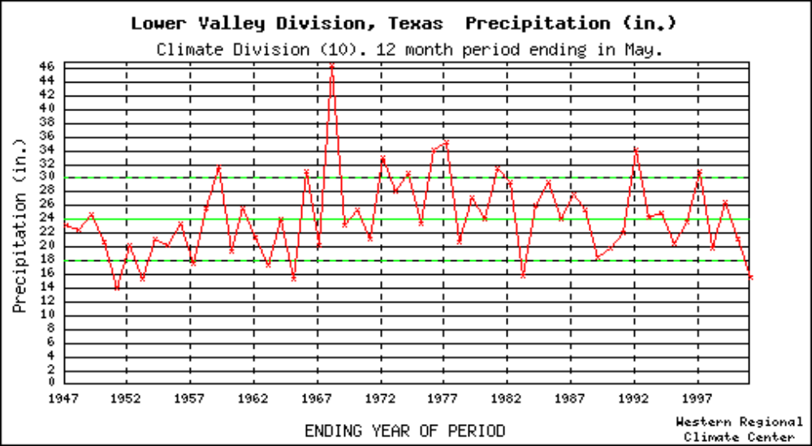

The drought has reduced run-off to all major and minor reservoirs and their tributaries in the Rio Grande Basin. Operating reserves for the Falcon-Amistad system, as well as for many reservoirs in the Mexican portion of the basin, are at all-time lows. Mexico currently is down to about 10% ownership of its normal capacity of water in the Falcon-Amistad system (Rubinstein, 6/26/02), and Conchos basin reservoirs are now storing between 21% and 22% of the amount of water they are capable of storing (IBWC; from storage conditions posted on website). Figure 4 shows current capacity in the Amistad/Falcon system, while Figure 5 provides capacity for 3 major reservoirs on the Río Conchos and one on the Río Salado.

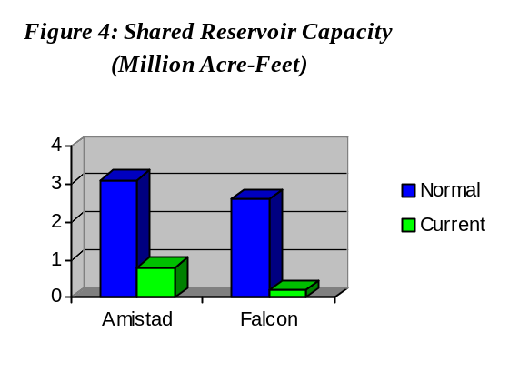

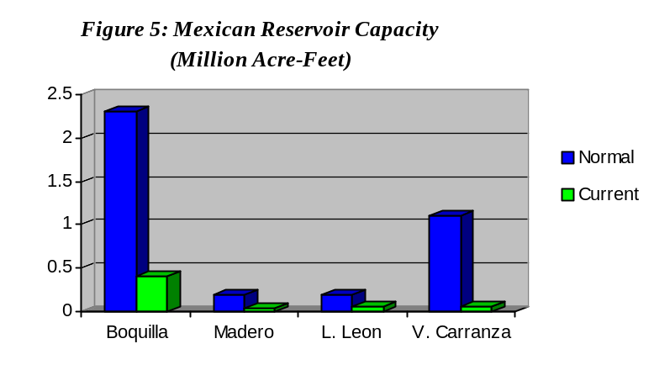

A 1944 Treaty between Mexico and the United States governs allocation and management of the binational Río Grande. Briefly, this treaty divides the shared waters of the mainstem equally and allocates to the U.S. one third of the flow reaching the Rio Grande from certain specified tributaries. It also provides that Mexico must make available to the United States an annual minimum flow averaging at least 350,000 acre-feet/year over a 5-year period.

At the end of the 1992 – 1997 accounting cycle, by the terms of the 1944 Treaty, Mexico was to have delivered a total of 1.75 million acre feet of water to the U.S. At the end of this cycle, Mexico was 1,023,849 acre-feet behind on its obligation (IBWC 2002 at 4).

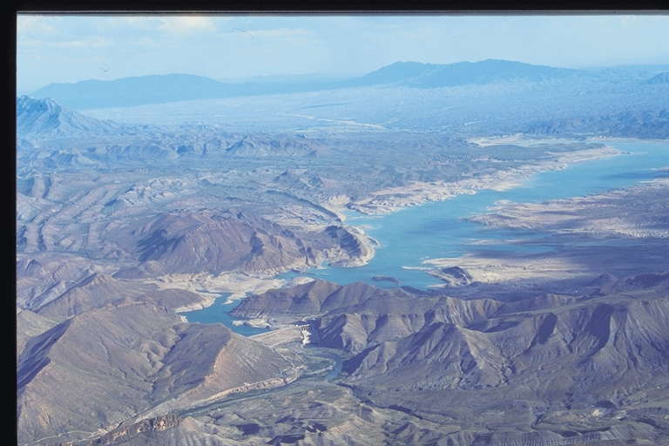
El Granero (Luis Leon) Reservoir,
on the Rio Conchos

Photo:
David Lauer

Article 4 of the 1944 Treaty provides that in the event of “extraordinary drought or serious accident to the hydraulic systems on the measured Mexican tributaries, making it difficult for Mexico to make available the run-off of 350,000 acre-feet annually…any deficiencies existing at the end of the…five-year cycle shall be made up in the following five-year cycle with water from the said measured tributaries.” (emphasis added).

Mexico asserts that through deliveries of water from the measured tributaries and allocation of water to the U.S. that would otherwise be credited to Mexico, it delivered sufficient water by May 2001 (according to a statement from the Mexican Embassy) to cover the 1992-1997 cycle, and that its deficit under the current (1997-2002) cycle is payable during the 2002-2007 cycle. As discussed in more detail below, Mexico has not made sufficient deliveries or allocations to the U.S. to also meet the minimum 350,000 acre-feet/year obligation for the 1997-2002 cycle.

Some U.S. interests have argued that a 1969 “minute” to the 1944 Treaty (Minute 234) obligates Mexico to both pay the debt from the 1992 to 1997 cycle, together with any quantity of water which is needed to meet the minimum 350,000 acre-feet per year delivery requirement for the previous - 1997 to 2002 - cycle (Minute 234 @ para. #2). Mexico responds that this would be difficult, if not impossible, if it has experienced an extended period of below average rainfall – a condition that it asserts constitutes “extraordinary drought” (CNA 2000). The Treaty does not define “extraordinary drought,” and one could argue that the five-year accounting cycle provisions seem not to directly contemplate a drought that lasted longer than five years.

As of April 2, 2002, Mexican deliveries/allocations to the U.S. for the 1997 to 2002 cycle totaled 1,127,944 acre-feet. While final accounting will not be complete until the end of September 2002, it appears that without heavy rains this summer, Mexico could have a deficit approaching 1.7 million acre-feet by the close of this five-year cycle.

The Rio Conchos’ importance to Rio Grande flows

Once it reaches Fort Quitman, about 100 miles downstream of El Paso, the Río Grande is essentially an accidental river – it’s upper and lower portions largely disconnected (Collier 1996). Most of the water delivered to the Texas state line from the Elephant Butte/Caballo reservoir project in New Mexico is used for municipal and irrigation needs for the city of El Paso and for the Hudspeth County and El Paso County irrigation districts. The Rio Grande Compact of 1938, and the 1906 U.S./Mexico Convention (which provides for 60,000 acre-feet annual deliveries to Ciudad Juarez) largely governs operation of these reservoirs. For more information about issues concerning the upper Rio Grande of Texas, visit the Paso del Norte Water Task Force website.

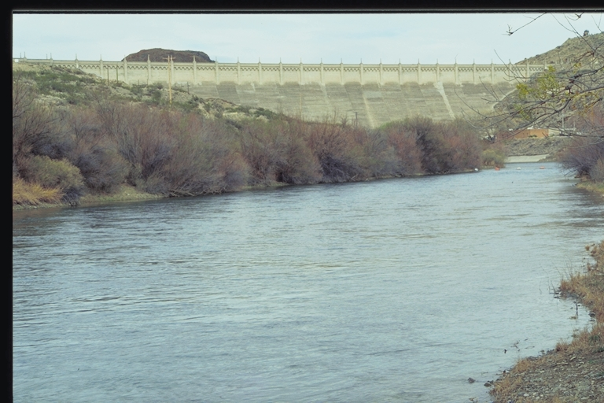
Elephant Butte Reservoir,
Truth or Consequences, New Mexico

Photo:
David Lauer

Flows in the river downstream downstream of Fort Quitman are largely poor quality irrigation return flows (containing high levels of salts). During most of the year, the other local arroyos and drainages discharging into the Rio Grande contribute small amounts of runoff from brief showers, and also pile up sediment and rocks into the river from flash floods. This segment of the river is also choked by invasive salt cedar, or tamarisk, which has virtually taken over the channel of the river for about 150 miles. This Eurasian species was introduced sometime in the 1800’s and spread rapidly – today it covers over a million acres throughout the South and West (TCPS 2001). Due to lack of attention and political will to correct the extensive ecological damage in this river segment, it has been dubbed the “Forgotten River.”

In June of 2000, former U.S. Interior Secretary Bruce Babbit and former Mexican SEMARNAT secretary Julia Carabias, due to a mutual concern with conditions in the Fort Quitman to Amistad stretch of the Rio Grande (which includes the Forgotten River), signed a Joint Declaration in Ciudad Juarez. The purpose of the declaration is to “expand binational planning efforts to improve and conserve the natural resources of the Rio Grande/Rio Bravo and associated habitats.” A working group was formed (called the Binational Rio Grande/Bravo Ecosystem Working Group, or BREW) to implement the Joint Declaration. The group has met several times and is focusing its efforts largely on data gathering and pursuit of small-scale saltcedar removal/restoration projects on public land. For several reasons – the water deficit, lack of funding, and turnover in both administrations since the declaration was signed – concrete progress on the stated objectives of the Joint Declaration has been elusive.

Even prior to the BREW, a loose coalition of individuals representing a variety of professional affiliations (both public and private) had met on several occasions to discuss conditions in the Forgotten River stretch and strategies for focusing more attention and resources to the problems there. The group, calling itself the Forgotten River Advisory Committee, continues to meet and has fostered several initiatives, including an exploratory cultural and natural heritage tourism route to enhance the economic value of the Forgotten River region.

The effective separation of the upper and lower portions of the Río Grande is one reason why the Río Conchos is so important to downstream flows, storage in the international reservoirs on the mainstem and flow to the estuary at the mouth of the Río Grande. Entering the Río Grande just above Presidio/Ojinaga, the Conchos provides on average about 35 to 40% of the flows in the Rio Grande from that point downstream (Collado, 2001). Combined flows from the Rio Salado and Rio San Juan, which enter the Rio Grande from upstream and downstream of Falcon Reservoir, respectively, provide an additional 35 to 37% of Rio Grande flows (IBWC, various years).

Irrigation in the Río Conchos Basin and the Lower Río Grande Valley of Texas

Throughout much of the transboundary Río Grande basin, irrigated agriculture accounts for 80 to 90% of surface water use. Municipal use of surface water, while increasing, generally accounts for 10 to 20 % of total use. Some major municipalities, particularly those in the Río Conchos basin, rely primarily on groundwater.

This section briefly discusses irrigation water use and crop production trends in two key areas of the basin: the Río Conchos in Chihuahua and the Lower Río Grande Valley of Texas.

There are three major irrigation districts in the Río Conchos basin: Río Florido; Delicias; and Bajo Río Bravo.

Delicias is the largest of these three districts. Here, surface water from La Boquilla and Madero reservoirs, along with groundwater pumped from local aquifers is used for irrigation of pecans, alfalfa, chiles, and peanuts (major crops). Other, minor, crops grown in Delicias include onions, tomatoes, melons, wheat, and, in some years, cotton and sorghum.

According to the Delicias office of Mexico’s agricultural finance authority, FIRA, during the last decade of water scarcity, many small farmers have stopped growing wheat or corn, but are instead renting or selling their water rights to other farmers who are growing alfalfa, peanuts or chiles. Planting of cotton has also declined significantly. These declining crops (corn, wheat, sorghum and cotton) also have less commercial viability for Mexican farmers due to low prices. In fact, FIRA predicts that the future for Delicias farmers lies largely in the cultivation of alfalfa for the Chihuahua and Coahuila dairy industries. (FIRA study at 3, 5, 8, 21-28).

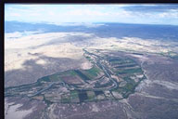
Delicias Irrigation District, Chihuahua
Photo:
David Lauer

Trends in the Delicias District show that surface water releases for irrigation have decreased 31% for the period 1993-2000 in comparison with the period prior to 1992 (Jimenez 2002). In all but 1997, no releases of water have been made for Fall-Winter irrigation cycles (FIRA at 6). Figure 6 illustrates decreases in irrigated land in Delicias, with the most dramatic drop appearing in 1995 and 1996. It appears that in 1997 and 1998 irrigation releases increased in response to increased run-off, but not enough rain fell after 1997 to replenish supplies, and the deficit mounted.

It is important to note that irrigation in the Conchos basin is supplemented with groundwater supplies. For example, in 1995, when Delicias farmers were particularly hard hit by drought and declining surface water supplies, CNA reports that 286 new groundwater wells were drilled in the Meoqui-Delicias aquifer (Jimenez at 8). Thus, an increase in irrigation in the Conchos basin does not automatically mean a corresponding increase in surface water use.
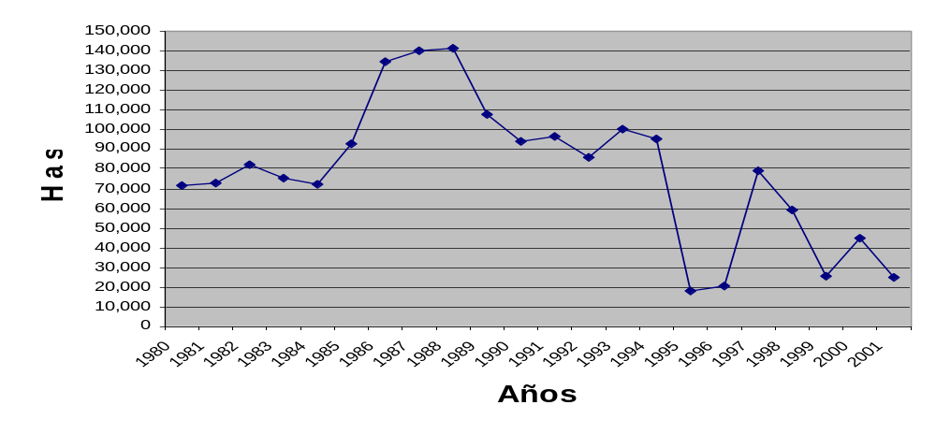Some reports have discussed the potential that increased groundwater pumping in the Conchos basin might have for decreasing surface water flow in the Conchos, but there is no concrete data to support this claim. In fact, in some instances increased groundwater pumping from aquifers not associated with the Río Conchos and subsequent discharge to the river as irrigation return flow might increase flows in the Conchos. Considerably more data is necessary before any conclusions can be drawn on this point.
Figure 6: Trends in irrigated hectares in the Delicias Irrigation District 1980 – 2002

It is also important to note that efficiency ranges considerably from district to district. Overall, in the three major Conchos irrigation districts (Bajo Río Conchos, Delicias and Río Florido), about 62% of canals are lined, and 38% are unlined (Jimenez at 13). Overall efficiency of irrigation system deliveries is 40%, mainly due to low application efficiency. Efficiency in the distribution of water in the large canal conveyance and minor canal systems is as high as 80% (Jimenez at 13).

In the Lower Rio Grande Valley, major crops include cotton, grain sorghum, sugar cane, vegetables and citrus. Figure 7 shows total number of irrigated acres for the 4-county area from 1992 to 2000.

Water conveyance efficiency rates in LRGV irrigation districts average around 64% (Fipps), with a low of 40% in the San Benito district and a high of 95% for one Hidalgo County district (Fipps, 1998 at 15). Potential water savings in LRGV irrigation districts might be as high as 223,000 acre-feet of water if all districts were boosted to 90% conveyance efficiency (TWRI).

There are conflicting estimates regarding the losses Valley farmers have suffered over the past few years as a result of reduced water availability. A joint Texas Water Development Board/Texas A&M report authored by John Robinson at the Texas A&M Research and Extension Center at Weslaco estimates that each acre foot of water is worth $652 in business activity to the region (Robinson at 1). While this report states that “an evaluation (of losses) based on Mexico’s historical deficits is beyond the scope of this study due to complicating factors...” some Texas politicians extrapolated from the report a loss figure of $2.2 billion dollars for the six-year period, which was later adjusted down to $1 billion. It is unclear how the original $2.2 billion figure was arrived at, but it appears the $1 billion figure comes from multiplying $652 times the actual amount of the current deficit (1.5 million acre feet) = $978,000,000. This assumes that many other factors – such as market price, crop choice decisions and urban conversion of land - are stable or unchanging. It also assumes that farmers would receive their full allocations of water regardless of other factors - such as cities’ water needs, drought conditions, local rainfall, evaporation rates, sale or lease of irrigation water to urban uses, etc. In reality, these factors can and do fluctuate a great deal from year to year.
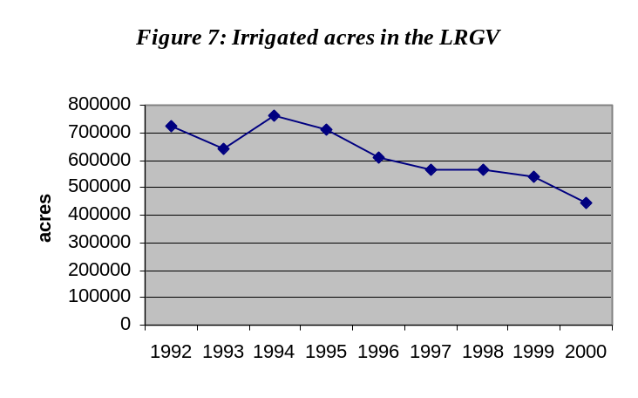

A report by the USDA released in April 2002 is inconclusive regarding the direct losses to agriculture in the LRGV as a result of the deficit. In fact, the report states that researchers were “unable to quantify such losses for several reasons” – among these “lack of data,” “incomplete data” and “numerous confounding factors that have affected planted area in the region during the period of deficit deliveries.” The report states that harvested acreage of field crops in the area fell sharply during the three-year period from 1996-99, but then began to rise again in early 2000. The report summarizes that lack of water availability was a factor influencing crop choices during the drought and deficit period, but that other factors independent of water availability also played a role.

For example, following the drought year 1995, cotton acreage was reduced throughout the state of Texas, even in areas not dependent on Rio Grande water. And, while citrus is affected by lack of water availability, citrus in the LRGV has never fully recovered from the affects of two freeze years (1983 and 1989) that decimated much of the crop. Considering the many factors affecting crops in the LRGV during this time, (below-normal precipitation, production losses from earlier years, insect losses, freezes, low crop prices, rising production costs, etc), the water deficit certainly compounded these problems. The report does state “annual average value of the decline in production of field crops during 1996-99 compared with 1990-95 was $34 million” (USDA 2002).

There is very little official information regarding economic losses in the Conchos basin as a result of drought. News reports on the state of agriculture in the Conchos region quote local farmers as saying that there is only a handful of farming operations in the area capable of making any investment in irrigation infrastructure, and these farmers are the ones staying solvent, while others are facing dry fields. Other reports say that that decreased harvests in the Delicias Irrigation District has cost some $78 million in annual revenue since 1992. With reservoir levels in the region at only 20%, it seems likely that surface water irrigation use will continue to be cut back, and farmers may increasingly turn to groundwater wells to stay in business.

Clearly, farmers in both the Mexican and Texas portions of the Río Grande basin have suffered and are suffering the effects of low rainfall and decreased run-off. Agricultural data on both sides of the border reveal that, in addition to water availability, factors such as previous investment crop prices, credit availability and land prices have contributed to changes in crop choices (USDA at page ii and FIRA at 3, 5). In essence, in times of reduced water supply, water is being shifted to perennial and/or higher value crops (pecans, chiles, peanuts and alfalfa in Delicias and sugarcane, vegetables and citrus in the Lower Río Grande Valley).

Escalation of the debate, Mexican protests and calls for water in Texas

Farmers in the LRGV began experiencing cutbacks in irrigation water in 1996 (Phillips, 2002). By 1998 a larger portion of irrigation districts had received cutbacks in water accounts (Phillips). In late 1997, the U.S. Section of the International Boundary and Water Commission (IBWC) initiated consultation with the Mexican section on the amount of water in deficit for the 1992-1997 cycle, and discussion ensued. In March 1998, the Mexican section agreed on the amount in deficit and offered a plan to repay the deficit with water from tributaries named in the 1944 Treaty, should the volume of flow in those tributaries have exceeded 1,050,000 acre-feet/year.

Over a year later (April 1999), the U.S. section of the IBWC officially rejected the offer, calling instead for Mexico to release water from reservoirs on Treaty tributaries to cover the deficit. The IBWC also wanted “more detailed information” on “conditions” in the Treaty tributaries.

At technical meetings in early 2000, Mexico replied that it could not make such releases because it was suffering from extreme drought, and again offered to initiate repayment when flows over a certain amount became available in Treaty tributaries. The U.S. section continued to press Mexico to operate its reservoirs in order to make repayment deliveries. At this time, Conchos basin reservoirs were at about 26% of capacity, and reservoirs in the Salado basin were at 11% of capacity (IBWC at 4).

By this time, the Secretary of Rural Development in Chihuahua was pleading for federal assistance to combat the drought, and farmers in small “ejidos” in Chihuahua, according to the Mexican press, were finding it increasingly difficult to commercialize their products in the new global marketplace. While Texas farmers claimed that Mexican products were being irrigated with “their” water, only to be exported to the U.S., Chihuahua farmers conducted strikes in protest over trade practices that they said made it impossible for them to compete, and asked the government to block imports from the U.S.

Although no overall agreement was reached in early 2000, Mexico did transfer ownership of 137,821 acre-feet in Amistad/Falcon to the U.S. in March 2000, and agreed to temporarily assign its 50-50 flows to the U.S., which provided an additional 163,547 acre-feet (IBWC at 5).

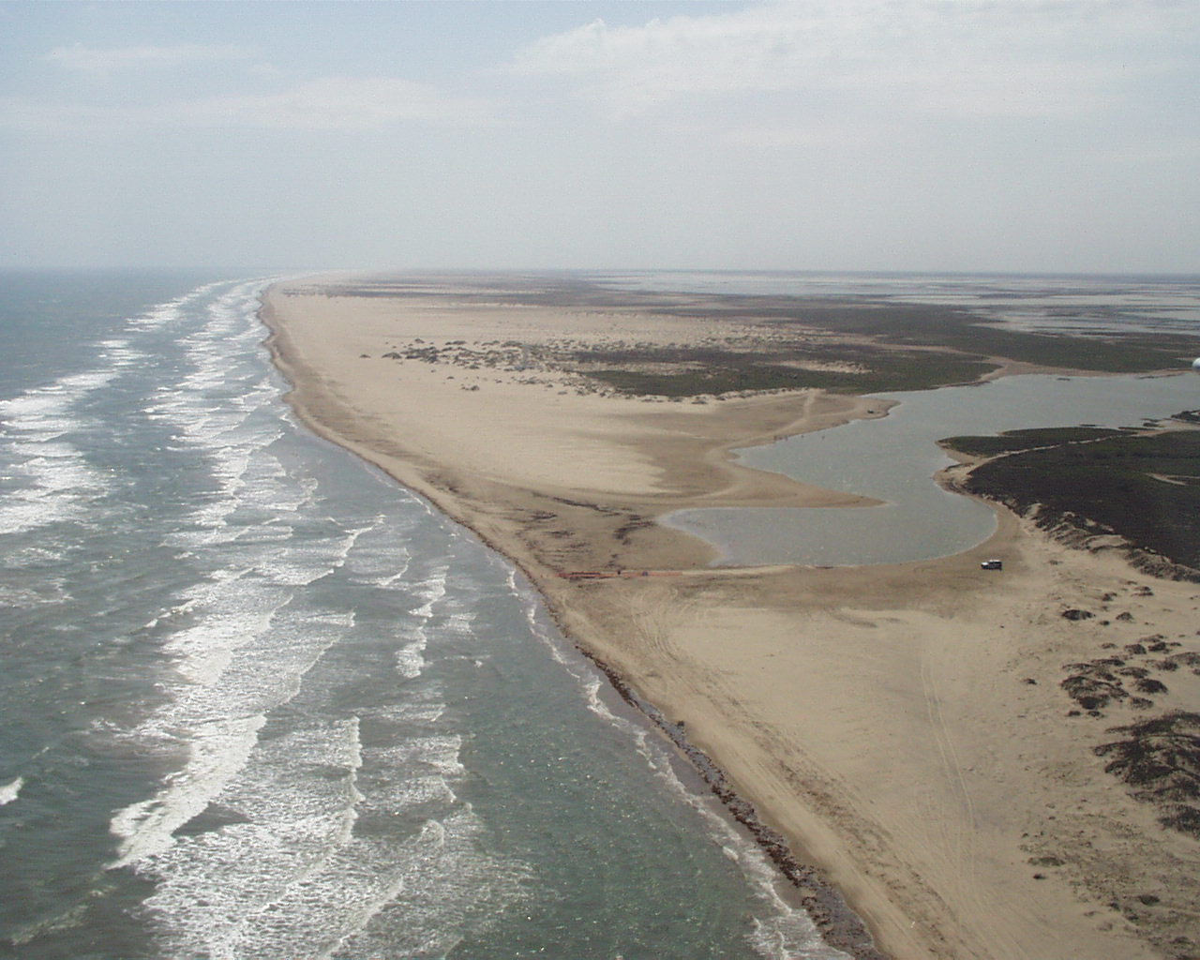
Press reports on Mexico’s water deficit began appearing more frequently in 1999, when LRGV farmers voiced concerns publicly about lack of water in the Falcon-Amistad system and decreased inflows from the Río Conchos. In February 2001, the Rio Grande did not have sufficient flow to reach the Gulf of Mexico, and a sandbar developed at the river’s mouth. The sandbar remains to this day, despite a one-time attempt by the IBWC to dredge an opening to the Gulf.

Mouth of the Rio Grande at Boca Chica

Photo: Randy Blankinship

By early 2001, the U.S. and Mexican sections of the IBWC had hammered out an agreement, presented at a meeting between Presidents Bush and Fox on February 16th, 2001, and signed as Minute 307 of the 1944 Treaty a month later, on March 16th, 2001. Minute 307 indicated that Mexico would make deliveries of 600,000 acre-feet toward repayment of the deficit. This estimate was based on projected rainfall and runoff to both measured (Treaty tributaries) and unmeasured (non-Treaty) tributaries, and transfers from Luis Leon Dam in Chihuahua and Venustiano Carranza (Don Martín) Dam in Coahuila.

In Minute 307, both governments also affirmed their commitment to “work jointly to identify measures of cooperation on drought management and sustainable management of (the Rio Grande) basin,” setting the stage for developing long-term solutions to the present conflict.

On May 16, 2001, a total of over 20 public interest, conservation and human rights organizations in the U.S. and Mexico issued a binational declaration regarding Minute 307. The declaration requested that the two governments incorporate a number of measures in the drought management plan and sustainable management plan for the basin aimed at protecting ecosystem functioning through water use efficiency and other means. The declaration also requested that interested stakeholders be involved in providing input to such a plan.

Prior to Mexico initiating payment to the U.S. under Minute 307, however, and after the deliveries made in 2000, farmers in both Taumaulipas state and the state of Coahuila lodged bitter protests. Tamaulipas farmers – particularly the 14,000 members of Irrigation District 025 in the Río Bravo area - had been trying to get crop damage payments from the federal government for over a year, without success. The 025 Irrigation District had already seen its share of troubles (and had complained to the CNA and the Tamaulipas state government) over the construction and operation of El Cuchillo Dam some years before, built to supply water to the burgeoning city of Monterrey. In effect, the new dam diverted water away from the Marte R. Gomez dam, which supplied a bulk of the irrigation water to the district. It appeared that any transfer of Mexican water to the U.S. that might have gone for Tamaulipas’ agricultural use, therefore, would compound the injury to Tamaulipas farmers. Farmers in 025 took over and occupied regional Tamaulipas CNA offices in July 2001 in protest over the unpaid indemnities promised and over further transfers of Mexican water to the U.S., and a month later filed an injunction in Mexican federal district court that temporarily suspended transfers of water to the U.S. under Minute 307.

At the same time as the protests were heating up in the 025 Irrigation District, farmers and fishermen in the Mexican state of Coahuila were also feeling the pinch. In January 2001, a strike by fishermen and irrigators in the Don Martín (004) Irrigation District, located at the junction of several rivers, including the Río Salado west of Nuevo Laredo, had halted transfers from Venustiano Carranza Dam to the U.S. The local villagers – some 15 to 20 citizens – maintained a vigil at the gates of the dam for 24 hours for several weeks. Their principal concern was that drawing down the level of the dam would ruin the fishing and tourism industry they had become dependent upon. The villagers lost their battle, however, and eventually the dam was re-opened, and water from the Carranza was delivered to the Rio Grande toward fulfillment of Minute 307.

In addition, predicted run-off flows in the unmeasured tributaries during the summer of 2001 were much lower than even the conservative averages used as a basis for Minute 307, making it even more difficult for Mexico to meet the projected goal of 600,000 acre-feet (IBWC at 10)

In August 2001, IBWC/CILA issued a Joint Memorandum concerning a meeting held in Ciudad Juárez between the two sections, the Texas Natural Resource Conservation Commission, U.S. Bureau of Reclamation, Mexico’s Foreign Relations Secretariat (SRE) and the Mexican Comision Nacional del Agua. The intent of the meeting was to exchange ideas about improved basin management as stipulated in Minute 307. In the Memorandum, the parties agreed to continue efforts to meet Minute 307 goals, conduct a tour of Mexican dams, hold a follow-up meeting in Austin, and form a binational work group to convene a summit on sustainable basin management. The parties also agreed that increased public access to IBWC information and data was important, as well as cooperative information exchange between IBWC and CNA on interior Mexican reservoirs. The parties agreed to work with the University of Nebraska to initiate an emergency management plan for the current drought situation. Progress on these initiatives is uncertain, as political pressure and rhetoric in both countries seems to have stalled further collaboration.

In November 2001, partially in response to involvement from the Texas Secretary of State’s office and requests from Texas officials to “assess” the status of Conchos region reservoirs, Chihuahua governor Patricio Martinez hosted a visit, including a flyover, in the Río Conchos basin. After this visit, Texas farmers appeared even more frustrated, claiming that Chihuahua was planning to develop more water from the Río Conchos to provide for an expanding agricultural base. Texas farmers increased their calls for water from Chihuahua.

The Mexican federal government succeeded in overturning the Tamaulipas injunction in February 2002. Mexico then made an immediate transfer of water to the U.S. from its reserves in the Amistad/Falcon system. Thus, Mexico made a total payment of 427,544 acre-feet toward the 600,000 agreed upon under Minute 307 (IBWC, 6).

By now, however, internal political pressure in both countries began to overtake technical talks and influence official negotiations, hindering, to some extent, progress on many other fronts. Approaching the 2002 irrigation season, farmers and some Texas elected officials pushed harder then ever for immediate transfers of water from Mexico. Texas Governor Perry issued a white paper and spoke at a rally in March, where the messages were essentially the same – that Mexico pay it’s debt to the U.S. immediately. The Governor threatened that “diplomacy will be over with” if Mexico did not meet these demands. Presidents Bush and Fox met in Monterrey on March 22nd, but no agreement was announced.

On May 9, 2002, U.S. ambassador to Mexico Jeffrey Davidow’s office issued a press release with the intent of “clearing up recent confusion” generated from press reports on the water deficit. In the release, Davidow states that under the 1944 Treaty, the U.S. has “consistently complied” with its obligation to deliver to Mexico 1.5 million acre-feet of water via the Colorado River traversing parts of Colorado, Arizona and California, and he called for Mexico to honor its obligations to deliver water to the Rio Grande. It should be noted that Mexico has complained in the past over the excessive salinity levels of Colorado River water delivered.

In response to Davidow, various Mexican officials insisted that Mexico did not currently have the water to make payments on the deficit. Then, in a phone call with President Bush on May 14th, President Fox agreed to provide a plan by which Mexico would attempt to begin meeting its 1944 Treaty obligations. But on May 29, 2002, the Mexican Congress passed a resolution stating that Mexico would not deliver water to the U.S. because its own citizens came first, and the drought made it impossible to provide any water to the U.S. in the short term. President Fox quickly cancelled a planned trip to Texas that was to occur in June.

Shortly after that, the press reported that Mexico might be seeking North American Development Bank funds for feasibility studies on irrigation infrastructure improvements (The Rio Conchos Watershed Management Project) that would help Conchos basin managers meet future water delivery obligations. In response, Texas officials wasted no time in issuing formal protests against such a measure. Governor Rick Perry, in a letter to EPA Administrator Whitman, requested that the federal government “refrain from funding this project and notify Mexico that it will be reconsidered when the treaty issues are substantially addressed.” Representative Solomon Ortiz (D-Corpus Christi) and Texas Agriculture Commissioner Susan Combs joined the governor in protesting any U.S. endorsement of funds to Mexico for this purpose. Meanwhile, Senator Kay Bailey Hutchison managed to secure a $10 million dollar appropriation for LRGV farmers in the Senate supplemental appropriations bill.

Current status

On June 28th, 2002, the U.S. and Mexican governments reached agreement on a variety of short-term measures to begin diffusing the dispute. Mexico agreed to make an immediate transfer of water in the Falcon/Amistad system to the U.S. in the amount of 90,000 acre-feet. This transfer will be contingent upon Mexico receiving sufficient rainfall to meet the municipal needs of its own citizens and re-establish the necessary municipal reserve in the Amistad/Falcon system. If sufficient rainfall does not occur to replenish this reserve, the U.S. will transfer the necessary amount back to Mexico. Mexico also expects to be able to deliver some 47,000 acre-feet in estimated run-off that will arrive to the Rio Grande from the present time until October 26th, 2002.

A financial package cobbled together in part from NADBank funds and in part from Mexican federal government investments totaling $85 million will pay for irrigation infrastructure improvements, primarily in the three northern Mexico states of Coahuila, Chihuahua and Tamaulipas. The U.S. will provide $5 million for water development projects and to design water management policies. NADBank funded improvement projects will be subject to certification by the Border Environment Cooperation Commission (BECC). Mexico estimates that in the short term, efficiency can be improved by about 20%, resulting in some 80,000 acre-feet of water conserved annually – a third of which would be available to the U.S. as part of the flow reaching the Rio Grande from Mexico. In addition, the U.S. agreed to try to locate additional funds for water conservation projects over the next four years, possibly from Border Environment Infrastructure Funds (funneled through the U.S. EPA) or additional NADBank monies.

The two countries also agreed to continue working on long-term measures, i.e. a drought management plan and sustainable management plan for the Rio Grande basin, that will ensure Mexico can make sufficient water available for its citizens while also meeting the terms of its obligations to the U.S. as described in the 1944 Treaty.

Several other measures are contemplated or already underway. Mexico and the U.S. plan to form a Basin Congress, or “Consejo de Cuenca”, to provide input to the planning process, and the Instituto Mexicano de Tecnología de Agua (IMTA - Mexican Water Technology Institute) is working on a management plan for the Mexican portion of the Rio Grande basin.

Appendix A—Bibliography and Resources

Collado, Jaime & Wagner, Ana I., Proyecto de Reglamento de Distribución y Uso de las Aguas Superficiales de la Cuenca del Río Bravo, 3a Versión, Instituto Mexicano de Tecnología del Agua (IMTA), September, 2001

Collier, Webb and Schmidt, Dams and Rivers; Primer on the Downstream Effects of Dams, USGS, Circular 1126, June 1996

Comision Nacional del Agua (CNA), Comentario al Documento Estadounidense “Analisis Preliminar del Deficit Mexicano de las Aguas del Rio Bravo, bajo el Tratado de 1944”, February 8, 2000

Fipps, Guy, Potential Water Savings from Improvements in Irrigation Districts and On-farm Irrigation in the Lower Rio Grande Valley of Texas – Progress Report and Initial Estimates, Department of Agricultural Engineering, Texas A&M University, December 1998

FIRA, Plan Piloto de Planeación Estrategica, Agencia Delicias, (not dated).

Jiménez González, Gerardo, Uso agrícola del agua en la Cuenca del Río Conchos, Asociado de Biodesert, A.C., May 3, 2002

IBWC, Flow of the Rio Grande and Related Data – from Elephant Butte Dam, New Mexico to the Gulf of Mexico, various years

International Boundary and Water Commission (IBWC) website: www.ibwc.state.gov
Report of the United States Section International Boundary and Water Commission, Deliveries of Waters Allotted to the United States Under Article 4 of the United States-Mexico Water Treaty of 1944, April 2002

Phillips, Travis, Behind the U.S.-Mexico Water Treaty Dispute, House Research Organization, Texas House of Representatives, Travis Phillips, April 30, 2002

Robinson, John, PhD, The Value of Applied Irrigation Water and the Impact of Shortages on Rio Grande Valley Agriculture, 2001, Texas Water Development Board, Department of Agricultural Economics, Texas A&M University, November 13, 2001

Rubinstein, Carlos, Rio Grande Water master, Presentation to Region M Water Planning Group in McAllen, June 26th, 2002

TCPS, Can Eliminating Saltcedar Save the Forgotten River?, October 2001 (www.texascenter.org/borderwater)

Secretaria de Agricultura, Ganaderia, Desarrollo Rural, Pesca y Alimentacion (SAGARPA) website: www.sagar.gob.mx

Texas Water Resources Institute (TWRI), A&M Researchers examine irrigation conveyance efficiencies in Valley, twri.tamu.edu/twripubs/WtrSavrs/v5n2/article-10.html

U.S. Department of Agriculture (USDA), Assessment of Drought and Water Availability for Crop Production in the Rio Grande Basin, Office of the Chief Economist, (www.usda.gov.us/oce), April 2002

Other Resources

Texas Center for Policy Studies’ Border Water home page

Río Grande/Río Bravo Basin Coalition news archives

Alliance for Río Grande Heritage (upriver from El Paso/Juárez)

Paso del Norte Water Task Force (El Paso/Juárez/Doña Ana)

Water Plan for Lower Rio Grande Valley of Texas

Centro de Investigaciones Sobre la Sequía, Chihuahua (includes link to Chihuahua Plan Hidraúlico)

Comisión Nacional de Aguas (Mexican National Water Commission)

Instituto Mexicana de Tecnología del Agua (IMTA)

Consejo de la Cuenca del Río Bravo

Hereinafter Río Grande.
This primer focuses on the transboundary portion of the Río Grande basin, below El Paso/Juárez. Recent low snowpack and rainfall in the upper portion of the basin, however, are causing New Mexicans to declare a state of emergency. (Johnson declares drought emergency; Albuquerque Journal, April 26, 2002)
This cycle ended on September 30, 1997 (IBWC at 4).
(The McAllen Monitor, 4/24/02, Editorial page, Special to the Monitor.
For more detailed information on water use patterns in the transboundary portion of the Río Grande, see Kelly, Mary E., Water Management in the Binational Texas/Mexico Rio Grande/Rio Bravo Basin, 2002 (available at www.texascenter.org/borderwater).
Mexican farms are dry too; San Antonio Express-News, 5/19/02, Alison Gregor.
Chihuahuan farmers say they are suffering as well; Austin American Statesman, 3/17/02, Susan Ferriss.
The first four paragraphs of this section are based on the chronology provided on pages 4-5 of the April 2002 IBWC report.
Agoniza el Campo Chihuahuense, El Diario de Chihuahua, 3/26/99
“50-50” flows are those waters of the mainstem of the Río Grande, other than the flow contributed by Treaty tributaries, that are divided equally between the U.S. and Mexico.
Perry Admonishes Mexico; McAllen Monitor, Elizabeth Pierson, 3/21/02.
Congress rejects giving water to the U.S., says border communities come first; TheNewsMexico.com, 5/31/02.

