The Generation and Management of Hazardous Wastes and Transboundary Hazardous Waste Shipments between Mexico, Canada and the United States Since NAFTA: A 2004 Update
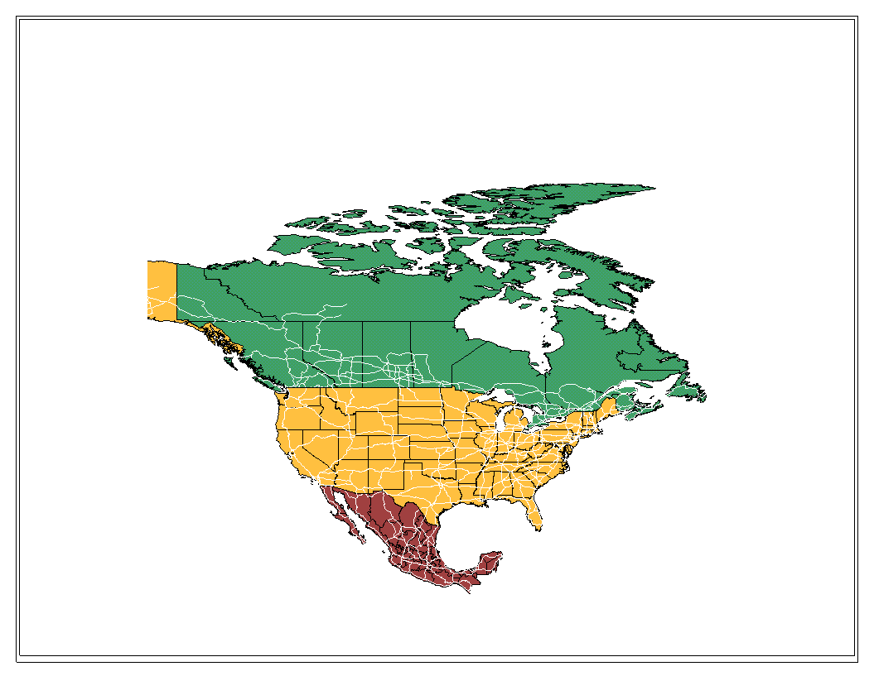
The Generation and Management of Hazardous Wastes and Transboundary Hazardous Waste Shipments between Mexico, Canada and the United States Since NAFTA:
A 2004 Update
Contributors:
Marisa Jacott, Fronteras Comunes

Cyrus Reed, Texas Center for Policy Studies
Mark Winfield, The Pembina Institute for Appropriate Development

July of 2004
44 East Avenue, Suite 306 * Austin Texas 78701
512.474.0811 phone 512.474.7846 fax

tcps@texascenter.org * www.texascenter.org

Note: An initial version of this report was presented at the Symposium on Understanding the Linkages between Trade and Environment sponsored by the North American Commission for Environmental Cooperation (CEC) in Washington, D.C. on October 11th, 2000 and then published in 2001. In 2003, the CEC provided a grant to update the original study. The authors would like to thank the CEC for providing a grant to assist in the preparation of this updated version of the report. The views contained herein, however, do not necessarily reflect the views of the CEC, or the governments of Canada, Mexico or the United States of America.

Acknowledgements: In addition to the main authors, both J. Scott McClain of Austin, Texas and James Marks of Toronto, Ontario contributed in the research and writing of the report. We would also like to cite our appreciate of both Dr. Chantal Line Carpentier and Timothy Whitehouse of the North American Commission for Environmental Cooperation for overseeing the update of the report and for their helpful comments throughout. Finally, during the course of the research, numerous government officials in all three countries provided information that was requested by the authors. This information is cited in the footnotes and tables of the report.
EXECUTIVE SUMMARY

Building on a previous report published in 2001, this report reviews and updates information on the generation, management and shipments of industrial hazardous wastes – as well as policy and regulatory developments -- in Mexico, Canada and the U.S. It accomplishes this task in three basic steps. First, changes introduced through NAFTA and its institutions are described, including those that have occurred in the last three years. Second, the changes with respect to government policies, disposal capacity, waste generation and disposal and transboundary traffic since 1999 are outlined in the U.S., then Mexico, and then Canada. Third, possible explanations for these changes, including changes in waste generation patterns, disposal site availability, general economic conditions, policy and regulatory changes and changes in the commercial hazardous waste industry iself, are reviewed and assess. A conclusion and summary follow.
The report finds that NAFTA and its institutions have continued to play a part in issues related to industrial hazardous wastes. For example, several waste management companies have utilized the investor-state dispute process contained within Chapter 11 of NAFTA to seek redress for actions which they argue are tantamount to expropriation. Most recently, the Spanish company TECMED successfully won a tribunal against the Mexican government for failing to renew an operating permit. For this “expropriation,” the tribunal awarded the company $6 million. The action represents the second time that foreign companies have used the enforcement and regulatory actions by Mexican environmental authorities in denying a permit to a hazardous waste landfill to seek redress.
Similarly, citizens – particularly in Mexico and Canada – have continued to file citizen complaint for failure to effectively enforce their environmental regulations. In the last few years, three complaints – two in Mexico and one in Canada – have been filed for failure to enforce hazardous waste regulations. Finally, in 2001, the North American Commission for Environmental Cooperation identified regulatory differences between the three countries on hazardous waste tracking and disposal standards as worthy of both further study and action. In 2003, the CEC Ministerial Statement reconfirmed this commitment and adopted a specific resolution on proper disposal, management and tracking of hazardous wastes, directing the CEC Secretariat to identify priority wastes and improve tracking among other matters.
The 2004 decision by the U.S. Supreme Court to allow Mexican trucks to enter the U.S. past the 20-mile commercial zone – as required by NAFTA – could potentially allow Mexican trucks carrying hazardous wastes and products to operate throughout the U.S., though the actual impact of this rule is still probably several years away.
In terms of generation, the report finds that incomplete data in Mexico and Canada complicate the ability to assess trends in the generation of hazardous waste since NAFTA went into effect. Even in the U.S. – with a well-established hazardous waste generation data system – there are potential problems with underreporting. Still, the data in the U.S. suggests that hazardous waste generation among industrial manufacturing plants has not changed significantly between 1993 and 2001, the last year for which data is available. In 2001, manufacturing plants generated slightly more than 37 million metric tons (40.8 million short tons).
Information in Mexico on hazardous waste generation is still incomplete. While a 1994 study estimated that manufacturing plants generated some 8 million metric tons, in 2000, some 27,200 plants reported generating 3.7 million metric tons. However, Mexican environmental officials continue to believe the actual universe of hazardous waste generated in Mexico is significantly higher. Belying that fact, recent information available on a state basis showed that just seven states reported some 2.8 million metric tons of hazardous waste generated in 2003. In Canada, only Ontario has recently approved requirements for generators to report annual generation of hazardous wastes, but no totals have yet been made available. Estimates for the country range from two to five million metric tons per year.

Table A. Generation of Hazardous Wastes ( million metric tons) in three NAFTA countries
 | 2000 | 2001 | 2003
Canada | NR, estimate of 2-5 million tons | NR, estimate of 2-5 million tons | NR, estimate of 2-5 million tons
U.S. | NR | 37.0 | Not currently available
Mexico | 3.71 | NR | 2.85 (only seven states reporting)

Where does the waste go? In the U.S., an increasing amount of the waste generated was apparently being sent off-site. For example, treatment of hazardous wastes off-site increased from 6.0 million tons to 6.8 million metric tons between 1993 and 2001. Interestingly, the waste was going to fewer facilities as consolidation occurred in the commercial hazardous waste management industry. In 2001, more waste was reported flowing to a fewer number of landfills, incinerators, and hazardous waste-burning cement kilns. Consolidation, opposition to particular facilities and tighter air and waste regulations all appear to be factors in this trend.
Unfortunately, while Mexican data shows a clear trend in an increase in the number of facilities authorized to treat hazardous wastes – including incinerators, cement kilns, metal, battery and solvent recyclers – but not interestingly landfills – there is no public information on the amount of waste actually received by these facilities. In Canada, like the U.S., the consolidation of the waste commercial industry has led to a relatively few facilities accounting for the bulk of treatment. These facilities are concentrated in the provinces of Ontario and Quebec and include energy and metal recyclers as well as disposal units.
Imports and exports of hazardous wastes between the three countries have varied since NAFTA. Again, however, differences in data between the three countries and gaps make comparisons difficult. Interestingly, while hazardous waste generation and treatment data in the U.S. is better than in Canada and Mexico, information about imports and exports is significantly better in Canada and Mexico than in the U.S.
Based upon Canadian government information, exports of hazardous wastes from Canada to the U.S. have risen steadily since NAFTA. Most exports came from Ontario and most went to metal recycling facilities in the U.S. Total exports from Canada neared 350,000 tons in 2002, an historic high. Waste flows from the U.S. to Canada, on the other hand, have been more erratic, though higher. There was a steep rise in imports, particularly for disposal between 1993 and 1999, and then a rapid drop in total imports from a 1999 peak. The decline has been in imports for both disposal and recycling, with imports for disposal down to 230,000 tonnes in 2002 from 394,000 tonnes in 1999, a 42% decrease. Imports for recycling peaked in 1998, and then fell off, although not as dramatically as has been the case with imports of wastes for disposal. Overall imports to Canada topped 400,000 tons in 2002.
Waste flows from the U.S. to Mexico and vice-versa are difficult to assess. Based both upon U.S and Mexican data, it appears that the amount of one particular waste stream – K061 – electric arc furnace dust from the recycled steel industry – increased between 1993 and 1999 to a single Mexican receiver, Zinc Nacional in Monterrey, Mexico. U.S. data suggests there was a slight curtailment of exports of K061 in 2001, while Mexican data reports a continued increase. While U.S. data is silent about other exports, Mexican data suggests there has been an increase in different types of batteries – including lead acid batteries – being sent to Mexico. There is even less information on other types of wastes – including tires and electronic wastes –which are known to be flowing to Mexico.
Waste flows from Mexico to the U.S consist of two types. Under Mexican law and an agreement between the two countries, maquiladoras are required to return their wastes to the U.S. when the waste is generated by U.S. imports. “Return” waste from maquiladoras appears to be increasing, due both to better compliance and an improved reporting system in Mexico. This increase is also reflected in data in HAZTRAKS, a U.S. hazardous waste data tracking which was discontinued in 2003. It is important to note, however, that Mexican data shows much higher rates of export than HAZTRAKS data did. The other type of waste is largely made up of oil drilling residue, apparently from gas and oil drilling activities in eastern Mexico. However, this data is not captured in U.S. systems, and reflects authorizations to export rather than the actual volume of waste exported. Thus, despite some improvements in data, this report could not come up with an accurate account of volumes exported between the three NAFTA countries. Still, with the exception of hazardous wastes from the U.S. to Canada – which have declined in the last few years – there appears to be a tendency for these volumes to increase. Given that some waste categories – such as electronic waste, tires and used batteries – are not captured by tracking systems, the total amount of hazardous wastes flowing between the countries is probably higher than indicated by Table B.

Table B. Hazardous Waste Flows Between NAFTA Countries, 2002 in Metric Tons
 | Exports to U.S. | Exports to Canada | Exports to Mexico | Total NAFTA Exports
Canada | 350,000 |  |  | 350,000 (2002)
U.S. (1) | --- | 248,500 (U.S. Data)  415,000 (Canadian Data) | 130,000 (U.S. Data)  325,000 (Mexican data) | 378,500 (U.S. Data)  740,000 (Mexican and Canadian Data)
Mexico | 864,000 (2002)  111,000 Return Wastes from Maquilas (2002) | 0 | ---- | 975,000 (2002)
Note: (1) Because of differences in reporting requirements and definitions of hazardous wastes, the U.S., Canada and Mexico provide different numbers in terms of U.S. exports of hazardous wastes to the other NAFTA countries.
This report also analyzed the reasons for the likely increase in waste flows between the U.S. and Mexico as well as the apparent decline in waste flows from the U.S. to Canada. In terms of waste flows between the U.S. and Mexico, the increases of waste from the U.S. to Mexico is most related to the growing production of recycled steel in the U.S., improved tracking of the resulting waste, and the presence of a major recycler of those wastes in Mexico. In addition, while the data is limited, it appears that the presence of new recycling facilities in Mexico for both LAB and electronic waste may be attracting U.S. exports.
The growth in authorizations of exports from the Mexico to the U.S. are related on the one hand to better reporting and compliance by maquiladoras with waste return provisions in Mexican law, and to the other, new drilling operations in eastern Mexico and the need to properly treat oil drilling residues.
In our 2001 report, the principle and potentially disturbing finding was the dramatic growth in US waste exports to Ontario and Quebec and, in the context of a weakened regulatory environment, a significant increase in disposal capacity in those provinces. This report, however, found that US waste exports overall to Canada declined in the 1999 to 2003 period, while imports of materials for recycling from Canada actually increased substantially.
The decline is likely the result of financial and management problems with the key importers of waste into Canada – Safety Kleen and Philips Environmental Services -- rather than a reflection of the implementation of stricter regulations in Canada – which to a limited degree has occurred at the provincial level in Ontario and Quebec. With the sale in 2002 of much of Safety Kleen’s operations to Clean Harbors Inc, it remains to be seen to what extent U.S. exports to Canada will continue to decline.
The regulatory ‘gap’ that was identified as a key factor in the dramatic rise in imports to Canada for disposal remains, particularly with respect to land disposal in Ontario. Imports may increase again as the economic situation of importers improves, or new entrants arrive in the market, although the province’s new government has committed to impose land disposal restrictions along the lines of those in place in the United States.
In the context of the moderate strengthening of the provincial regulatory and approval regimes with respect to hazardous waste disposal in Ontario and Quebec since 2000, there is evidence that proponents of new disposal facilities are shifting their proposals to other provinces with weaker approval requirements. The recent transfer of a proposed thermal treatment facility for contaminated soils from Ontario to New Brunswick may be an example of this trend. This reinforces the need for a strong federal regulatory backstop to ensure that new pollution havens do not emerge, as standards are strengthened in locations that have been traditional receivers of waste imports.
The most important finding of this report continues to be the major data gaps in tracking the generation, management and shipments of hazardous wastes both within and among the three NAFTA countries. Specific concerns include:

- Both Mexico and Canada appear to be still years away from having an accurate count of hazardous waste generated on a facility by facility basis, making it difficult to plan for needed infrastructure and help promote pollution prevention. However, Mexico now has more comprehensive national data on waste generation and waste disposal facilities than does Canada
- After approval of an obligatory and publicly accessible PRTR in Mexico in 2001, with significant support from the CEC, Mexico finally approved the actual regulations implementing such an information system in 2004; the actual standards detailing the mechanism of the annual operating permit as well as which chemicals will be reported could take up to two years to develop however;
- While information on imports and exports of hazardous wastes from Mexico appears to have improved over the last three years, there continues to be a disconnect between what is actually “authorized” for import and export and what actually crosses the border;
- While the U.S. EPA has some good information on import and export notices, these notices do not actually provide information on volumes or types of waste, at least in a pubicly-accessible form. Recent efforts to summarize annual export data submitted by primary exporters should be applauded and continued at the federal level.
- While there is information in Mexico about facilities authorized to treat or manage hazardous wastes, there is little information about the amount of waste actually treated by these facilities;
- While the U.S. has for several years required reporting of the generation of hazardous wastes, there appear to be significant gaps in the information, and budget cuts have prevented the most recent disaggregated data from being queried on-line;
- Exemptions from reporting in U.S. law – under RCRA – for some types of recycling – including Lead Acid Batteries and some electronic waste -- as well as current proposals to make CRT monitors a “Universal” waste have led to a lack of manifest and/or export data on these wastes. These gaps are particularly worrisome given past problems with lead smelters in Mexico importing U.S. waste as well as with the well-evidenced problems of electronic wastes exported to China and other Asian countries;
- The October 2003 U.S. EPA proposal to change the definition of solid waste, allowing secondary hazardous materials that are generated and managed in a continous process within the same industry to be excluded from RCRA hazardous waste requirements, could lead to problems in tracking off-site transport of hazardous wastes, particularly across borders.
- While the U.S. EPA made some efforts to create a hazardous tracking system on its Southern Border, in 2003 funding was pulled from the HAZTRAKS database project, leaving the U.S. with no specific plan to track hazardous wastes imported from Mexico.
- Because scrap and used tires have been put on and off a “subject to control” list in Mexico, it is likely that thousands of tons of tires are flowing to Mexico, either for illegal dumping or burning in cement kilns, but the exact amount is unknown. Recent proposals to allow for even more imports for the purpose of burning them in cement kilns is worrisome.
Finally, the present report continues to find a worrisome trend of spotty and declining enforcement at TSDs, particularly in the southern U.S.. Another worrisome trend along the southern U.S. border – with the possible exception of California -- is the lack of an inspection and enforcement presence focused at the Ports of Entry. Despite millions of trucks that enter the U.S., and in some cases, trains, there is no national, funded effort to inspect and enforce RCRA provisions on manifesting, labeling and shipping hazardous wastes. Given the recent Supreme Court decision to allow Mexican trucks to enter the U.S. under NAFTA, proper inspection and enforcement of RCRA provisions is even more imperative.
The report does make some basic recommendations for both the governments and the CEC. These include:
- In light of the recent Chapter 11 decisions regarding S.D.Myers, Metalclad and TECMED which we believe ultimately undermine the right of Parties to enforce their own environmental standards rules, the three Parties must again revisit NAFTA's Chapter 11 provisions. Appropriate changes must be made to safeguard the ability of Parties to set and maintain environmental standards and make environmental policy decisions which they regarding as necessary to protect the health and environment of their citizens.
- Through the CEC, the three parties should reopen negotiations on transboundary environmental impact assessments, as mandated by NAFTA.
- The CEC should promote the interchange of successful experiences in North America of industries which have committed to and achieved source reduction and pollution prevention.
- The CEC should facilitate the interchange and cooperation among governments, institutes, academics and industry of information and technologies which promote pollution prevention and the development and use of cleaner technologies.
- The difficulty in tracking hazardous wastes across borders is a serious concern. All three countries should work to improve reporting and tracking of hazardous waste generation and disposal and strengthen the compatibility of their hazardous waste tracking systems. The 2003 decision by the Council to look into coordinating and improving these systems should continue.
- The CEC should make a specific focus on electronic wastes, particularly as countries develop take-back legislation. The NAFTA countries – through the CEC – should assure that electronic wastes can be tracked to assure that exports from one country to another, or indeed outside the region, are being properly handled.
- All three countries should agree on a system of common unique identifiers for facilities receiving transfers of PRTR listed substances in their national PRTR systems. This would facilitate the detailed analysis of transboundary transfers of PRTR substances.
- Mexico should finalize its standards governing its obligatory Pollutant Release and Transfer Registry -- known in Mexico as the RETC -- particularly those parts detailing both toxic releases and hazardous waste generation. As part of this effort, Mexico should conduct and make publicly accessible a complete inventory of the types and volumes of hazardous wastes generated and treated in the country. This knowledge should help Mexico develop a true policy of source reduction and the promotion of clean technologies.
- Mexican government officials must respect the right to environmental information and recognize the right to know the volumes, types and management of the waste generated by the industrial sector.
- Mexico should conduct a full needs assessment of hazardous waste management capacity and shortages, including opportunities for source reduction and reuse. The recently published draft regulations for its new hazardous waste law call for a basic diagnostic of waste which could serve as a model for this assessment. The CEC could play a role in coordinating this effort.
- Mexico should issue a definitive ruling that incineration and use of hazardous wastes as a fuel in cement kilns and other industrial furnaces is a disposal technology and therefore importation of hazardous wastes to such facilities is not permitted under Mexican law. This ban should include wastes “subject to control” such as scrap tires.
- Mexico should amend its proposed regulations to the new hazardous waste law (LGPYGIR) to make sure that facilities proposing to co-process hazardous wastes as fuels – such as cement kilns – require the same authorization process – including risk assessments -- as other managers of hazardous waste, such as incinerators, rather than giving a blanket approval to such practices. This should include both liquid hazardous wastes and solid waste such as used scrap tires.
- Mexico should reactivate and expand its SIRREP (Sistema de Rastreo de Residuos Peligrosos) which will allow it to know, inform and control the quantities and types of wastes moving across its borders. Providing information only on the number of authorizations or movements does not assure compliance with environmental legislation nor with integrated waste management methods.
- Mexico should incorporate notice requirements and public participation mechanisms for residents who could be impacted by new hazardous waste management facilities seeking permits or authorizations to operate into its new regulations for the hazardous waste law;
- Canada needs to establish regular national waste generation and disposal reporting requirements for hazardous waste generators, as well as a system to make the resulting information publicly available and accessible.
- Canada should adopt standards for "environmentally sound disposal" of hazardous wastes, as per its obligations under the Basel Convention. These standards should be at least comparable to the U.S. RCRA standards for land disposal, and the RCRA/Clean Air Act MACT standards for hazardous waste incinerators and other facilities burning hazardous wastes as ‘fuel.’ Canada should incorporate “derived from” and “mixing” rules into its definitions of hazardous wastes within the Export/Import of Hazardous Waste Regulations made under the Canadian Environmental Protection Act 1999.
- The U.S. should rescind or ammend RCRA regulations which exclude used batteries from export notification requirements to accurately track exports from the U.S. to Mexico and other countries.
- The U.S. should put both its proposal to change the definition of Solid Waste – designed to reduce regulations for hazardous waste being recycled – on hold, particularly until a better system to track wastes across borders is put in place.
- The U.S. should increase resources to border states to adequately inspect Ports of Entry for compliance with hazardous waste handling, transport and reporting requirements and increase cooperation between U.S. Customs and state, local and federal environmental authorities to track hazardous waste in a timely manner.
- The U.S. must come up with an alternative to HAZTRAKS, which was canceled in 2003. If HAZTRAKS was a less than stellar system for tracking hazardous wastes, its absence only makes it apparent that the U.S. does not have a timely, complete system to track its imports and exports of hazardous and other potentially dangerous solid wastes.

