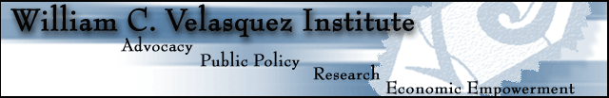
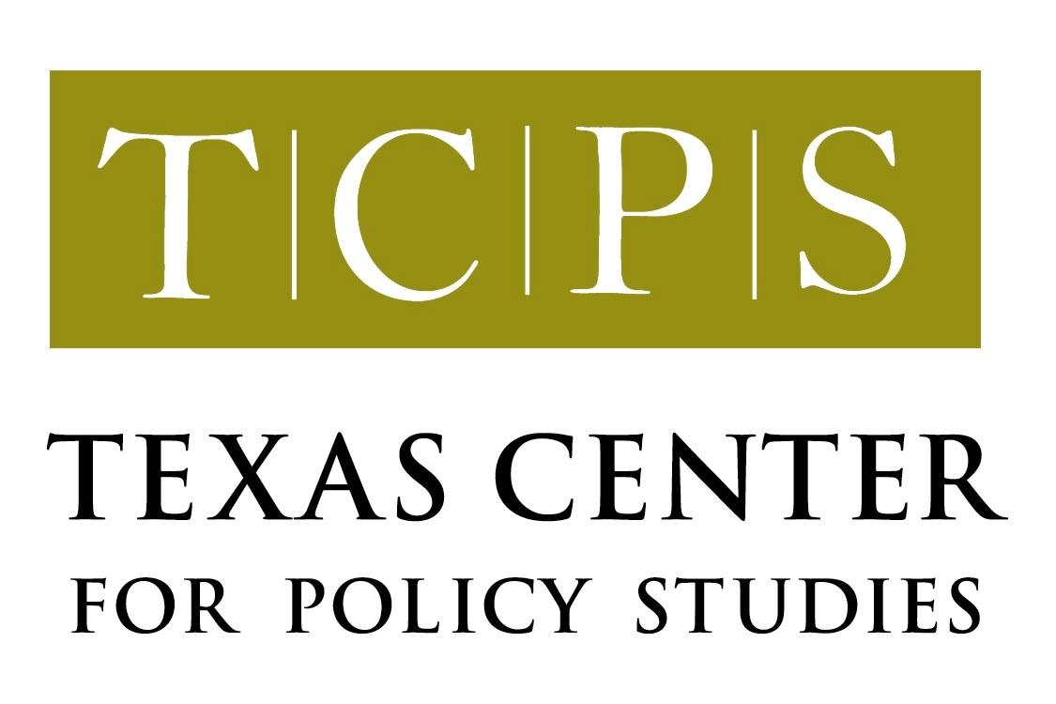

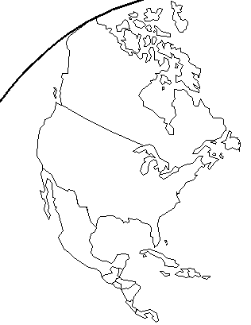
North American Integration and Development Center
School of Public Policy and Social Research
University of California, Los Angeles

FINDING COMMON GROUND:

A PUBLIC INTEREST PROPOSAL FOR
BECC/NADBANK REFORM

August 9, 2001

Contacts for comments or questions:

Texas Center for Policy Studies
Mary Kelly or Cyrus Reed
mek@texascenter.org; cr@texascenter.org;
44 East Ave., # 306
Austin, Texas 78701
(512) 474-0811; fax (512) 474-7846
www.texascenter.org

North American Integration and Development Center
Dr. Raúl Hinojosa-Ojeda
hinojosa@ucla.edu
School of Public Policy and Social Research
University of California
3250 Public Policy Building
Box 951656
Los Angeles, CA 90095
(310)206-4609; fax (310) 825-8574
http://naid.sppsr.ucla.edu

William C. Velasquez Institute
Rebecca Valdez
rvaldez@wcvi.org
2914 N. Main Street, 1st Floor
Los Angeles, CA 90031
(323) 222-2217; fax (323) 222-2011
www.wcvi.org
PUBLIC INTEREST OPTIONS PAPER
ON BECC/NADBANK REFORM

INTRODUCTION

Over the last several months, there has been considerable discussion of the performance and roles of the Border Environment Cooperation Commission and the North American Development Bank. The issues may even be discussed at a meeting between U.S. President George W. Bush and President Vicente Fox of Mexico in early September. In lieu of any detailed reform proposals being made available to the public by either government, this Options Paper is intended to offer a reform proposal that meets the goals and principles originally associated with the creation of the BECC and NADBank. The paper was prepared after discussions with several U.S. and Mexican government officials, non-governmental organizations and others interested in these issues, and considering the performance to date of the BECC and NADBank, as well as their original purposes.

This proposal if offered for consideration in both the U.S. and Mexico, with an eye toward accomplishing three over-arching goals:

- Maintaining the promise of NAFTA to improve the public health, environment and living conditions along the U.S./Mexico border;
- Opening the possibility of creating a broader “development bank” to foster North American economic integration; and
- Boosting community and economic development in those regions of Mexico where lack of opportunity has forced people to leave their homes and look for work elsewhere, including Mexico City, the border region and the U.S.

The paper also reflects several key principles that were at the heart of the BECC/NADBank’s creation during the NAFTA debate. These principles, which remain of critical importance, include:

- guaranteeing accountability, transparency, and wise use of public funds available to the BECC and NADBank;
- ensuring that the public and communities that benefit from or are affected by proposed projects have full access to information and an opportunity to comment on the project before certification and financing decisions are made;
- using the limited available resources for projects that benefit the public, improve the quality of life in the border region and promote sustainable development; and
- ensuring that the institutions have a fully binational character.

Nevertheless, it is important to acknowledge that the creation of the BECC and NADBank was an unprecedented experiment for the U.S. and Mexico. Not surprisingly, then, the agreement does have some flaws that should be addressed. Moreover, there have been understandable mistakes made during start-up and early operation of both institutions, though many of the most serious problems have been resolved. As much as it is important to acknowledge that reforms may be necessary, so must we recognize that much progress has been made—49 projects, with a total value of almost $ 1 billion have been certified, resulting in new water, wastewater and municipal waste projects being constructed throughout the border region. A few of the projects have encountered challenges in construction and start-up, but this new infrastructure will provide immensely valuable improvements in the environment and public health in the border. Many basic sanitation needs still remain in the border, however, and the BECC/NADBank work in this area is by no means complete.

Recent discussions have raised several issues about the BECC and NADBank. These issues fall generally into three categories, as summarized in Table 1.

Table 1. Major BECC/NADBank Reform Issues

ISSUE AREA | SUMMARY OF ISSUES
Functions of and division of responsibilities between BECC and NADBank regarding border environmental infrastructure projects | - Division of responsibilities;  - length, cost, value and other aspects of the BECC certification process;  - lack of follow-up for approved projects; and  - quality control and efficiency issues in the project development process
Unused lending capacity of NADBank and the need for investment in other types of infrastructure projects to reduce inequities between U.S. and Mexico and to improve trade and commerce throughout North America | - Less than $ 15 million of NADBank’s capital used for loans;  - most border environmental infrastructure projects requiring large grant components to be financially viable; and  - neither country, but especially Mexico, can afford to let resources sit idle.
Need to leverage resources and provide technical assistance for community and economic development in migrant-sending regions of Mexico | - Lack of economic opportunity in many regions of Mexico;  - the possibility of better leveraging remittances and providing technical assistance to foster community and economic development in these areas.

PROPOSAL

The following table outlines three inter-related reform proposals: (1) in lieu of any detailed alternative position for the creation of a single institution that would guarantee consistency with the goals and principles set out above, maintain the current division of responsibilities between the BECC and NADBank for border environmental infrastructure projects, but work towards improving the certification process and other aspects of project development; (2) allow NADBank to lend for non-environmental, non-border infrastructure projects, with adequate provisions for transparency, public participation and environmental assessment (BECC would not have a role in these projects); and (3) create a program within NADBank to leverage transnational remittances and technical assistance for community and economic development projects in migrant-sending regions of Mexico.

ISSUE AREA | PROPOSAL | RATIONALE
BECC/NADBank functions; Division of responsibilities | - Maintain current structure and division of responsibilities for border environmental infrastructure projects, as defined under recently expanded mandate.  - Use the BECC’s already-initiated review of the certification process to lay the groundwork for possible simplification and improvement of the certification process, with an opportunity for all interested parties to participate.  - Use the BECC’s already-initiated review of the procurement process to improve the quality and efficiency of project development and lower the costs of technical assistance; ensure early NADBank involvement in project development to avoid later conflicts.  - BECC and NADBank board, in consultation with interested parties could explore options for better project follow-up.  - BECC and NADBank general managers should be explicitly charged with resolving conflicts between the agencies. If the conflict cannot be resolved, it could be taken to a special “joint executive” committee composed of selected representatives from both the BECC and NADBank boards for resolution. | While it is admittedly not perfect, the number and size of the many projects already certified and finished or under construction demonstrate the essential viability of the BECC certification process. Moreover, the charter provisions and BECC rules that guarantee transparency, public notice, accountability and meaningful public participation are not by their terms applicable to NADBank, nor has the Bank adopted them. Thus, project development, technical assistance and project certification should remain in the BECC, as set out in the existing charter.  Maintaining the existing division of responsibility, versus transferring virtually all of BECC’s functions to NADBank (as currently proposed by the Mexican government) would accomplish the overall initial goals, while maintaining a separate institutional focus on the border (as promised with NAFTA and of clear interest to both countries). Moreover, merely transferring functions from one institution to another is no guarantee the process will be better. Instead, it is likely to lead to erosion of the transparency, notice, accountability and public participation guarantees provided by the current structure.
Unused NADBank lending capacity | - Devote $ 150 to $ 200 million of paid-in capital to the value lending fund (lower interest rates) for border environmental infrastructure projects.  - Increase the U.S. contribution to the Border Environmental Infrastructure grant Fund (BEIF), consistent with the NADBank’s 5-year outlook needs assessment.  - Allow most remaining paid in capital and callable capital to be used for lending to other infrastructure projects (i.e. non-border and non-environmental infrastructure). This new lending could apply to just Mexico projects or to projects in both countries. The U.S. and Mexico could also invite Canada to participate in this aspect of NADBank operations.  - These projects would not require BECC certification. However, the NADBank should develop a set of procedures, in consultation with interested parties, to provide for transparency and public participation in development and approval of such projects, as well as for environmental assessment and mitigation. | To fulfill the original promises of NAFTA and not leave the border short of resources, a specific portion of the NADBank capital should be set aside for border environmental infrastructure. The need for increased grant funding for water, wastewater and municipal waste projects, estimated to be about $ 950 between 2002 and 2005, is widely acknowledged.  Nevertheless, the need to effectively use remaining NADB resources in an appropriate manner cannot be ignored. However, because these are public monies and because some infrastructure projects (highways, pipelines, power plants, transmission lines) can have tremendous impacts on particular communities, the Bank would need a transparent, accessible process for developing and financing such projects. Without these guarantees, NADBank could face controversy and delay over projects that have adverse impacts on communities or the environment, even if the project would benefit North American trade and development.
Development in migrant-sending regions of Mexico | Create a specific program within NADBank, with a specific allocation of resources to:  - leverage transnational remittances for financing community and economic development in migrant-sending regions of Mexico; and  - foster transnational technical assistance for such projects.  This program should be designed in concert with grassroots organizations, rural finance experts and migrant associations in the U.S. and Mexico. It could build on or incorporate aspects of the current Community Adjustment Investment Program (CAIP) administered by the Bank. | The need for such development has been identified from many quarters, including Mexican President Vicente Fox. One approach is to develop appropriate mechanisms for leveraging the estimated $ 8 billion in annual remittances Mexicans working in the U.S. send back to their families and communities. Success in this endeavor could significantly reduce development inequities between the U.S. and Mexico.

For more information on BECC, see www.cocef.org; for more information on NADBank, see www.nadbank.org. See also the Texas Center for Policy Studies’ recent report on the performance of BECC and NADBank at www.texascenter.org.

